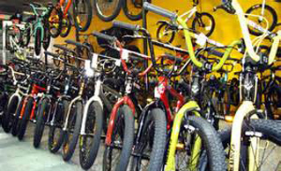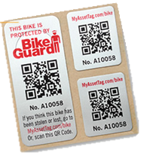 

**TAG**

**YOUR BIKE**

**How to Apply Your BikeGuard™ Asset Tags**



Enter Contact Information Here | 1127 Lombard Blvd. San Francisco, CA 59802 | phone 555.555.5555 | fax 555.555.5555

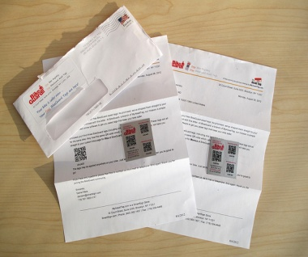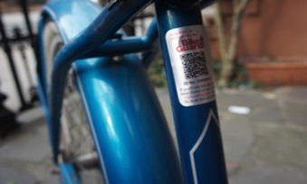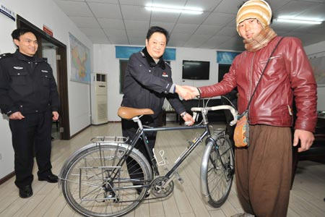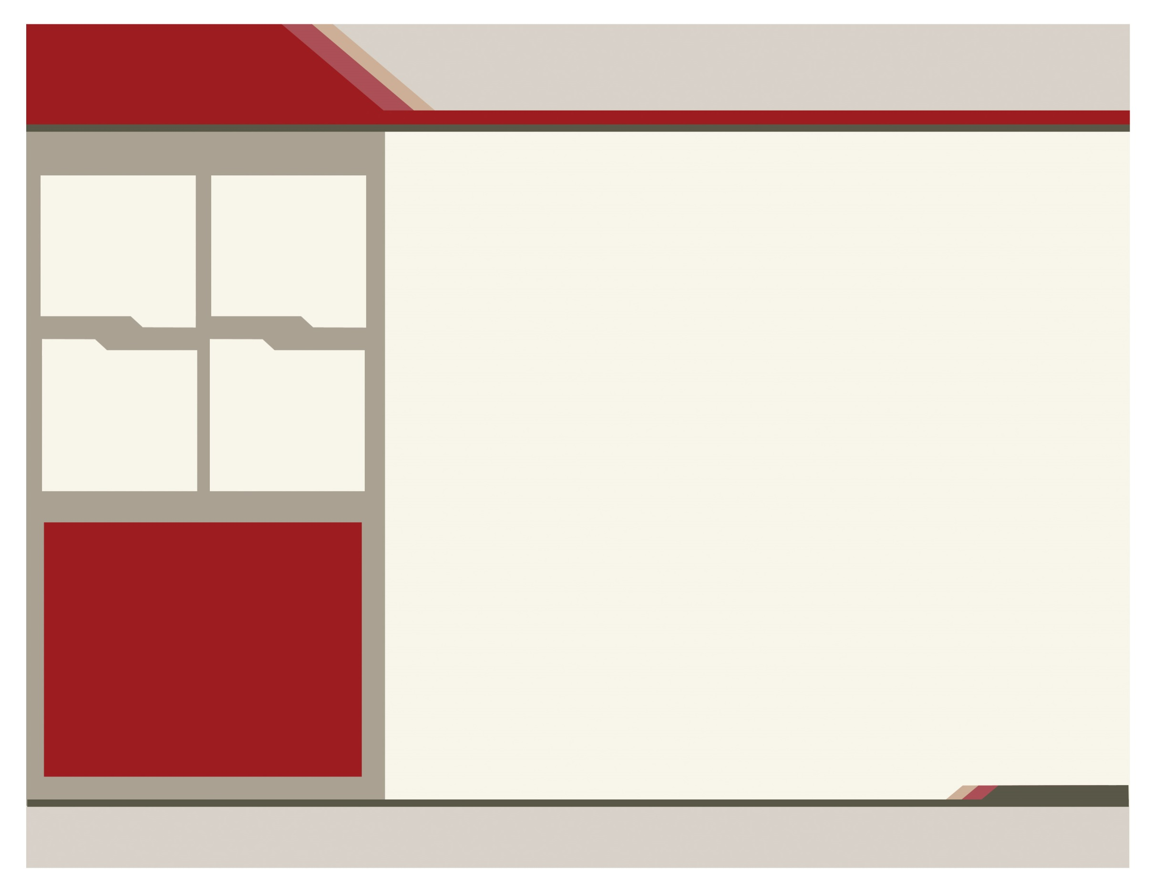

The Arizona Crime Prevention Association (ACPA) is a 501(c)3 Non-Profit Corporation created in 1977 by crime prevention officers, civilian employees, volunteers; and members of security and loss prevention industries. Their mission is to promote crime prevention awareness and reduce crime throughout the State of Arizona.

**WWW.ACPA.NET**

**www.myassettag.com/bike/**

**WHEN BUYING A NEW BIKE…**

* Record and safely store the make, model and serial # (located on the bottom of the bike, where the pedals attach).
* Register your bike with BikeGuard™.
* Place the asset tags on your bike.
* Let tags cure 2 days before riding it.
* Use a U-Lock to lock your bike.
* Make sure the U-Lock passes through the center of the frame as well as the wheel.
* Be safe and always wear a helmet!

**HOW DO THE TAGS STICK TO MY BIKE?**

The tags are backed with an adhesive that bonds permanently to your bike. The glossy, anodized aluminum layer has durable embedded print. They’re tamper-resistant and will conform to your bike. They can withstand heat, abrasions, and chemical exposure.

Once you receive the tags, peel off the liner and apply the tags (via their adhesive, directly to your bike). Suggested locations are shown above. Make sure that you place the tags on an unobstructed part of your bicycle where a smartphone will be able to scan them easily.

After applying your BikeGuard™ tags let them cure for two days so that the adhesive has a chance to really stick.

[**WWW.ACPA.NET**](http://WWW.ACPA.NET)

Every 7 seconds, a bicycle is stolen in the United States! While thousands of bicycles are recovered annually by Law Enforcement, very few are returned because there is no way to identify the bicycle's owner.

register IT

+ tag IT

= recover IT

**www.myassettag.com/bike/**

**How much does it cost?**

***Nothing!*** The BikeGuard™ system is **FREE** and includes bike registration, asset tags for each bike and shipping.

**How does it work?**

Upon registration, special asset tags are created and mailed to the bike’s owner with a unique, assigned ID number. This unique number is then used to catalog bicycles and their owners.

* RECOVER IT

**WHAT HAPPENS WHEN MY BIKE IS STOLEN?**

Every bike registered on BikeGuard™ is assigned a unique ID number, embedded on your asset tags. When your bike is found, Law Enforcement can identify and match the bike with the information you registered in the BikeGuard™ system either by entering the data manually or through their smartphone.

The ACPA has partnered with BikeGuard™ to provide a central clearinghouse for Arizona bike owners to register their bicycles for free. In turn, all law enforcement agencies throughout Arizona will have accessibility to quickly identify if the bike is registered, who the owner is and ultimately; reunite bicycle and owner.

**IT’S FREE**

**RECOVER IT**

**TAG IT**

**REGISTER IT**

* REGISTER IT

**WHY SHOULD I REGISTER MY BIKE?**

Registering helps reunite you with your bike if it’s ever lost or stolen. The BikeGuard™ database is used by Law Enforcement and bike owners to identify and return stolen or found bicycles. To register, you will need the bicycle identification number (serial #); usually located on the bottom of the bike’s pedal crank or bracket area.

**Register online at:**

**www.myassettag.com/bike/**

* tag IT

**What is BikeGuard™ The Free Bike Registry?**

A web based service that once registered, provides your bike with identification tags so if it’s ever lost or stolen, you will have a better chance of getting it back.



**WWW.ACPA.NET**